Page 1 of 2
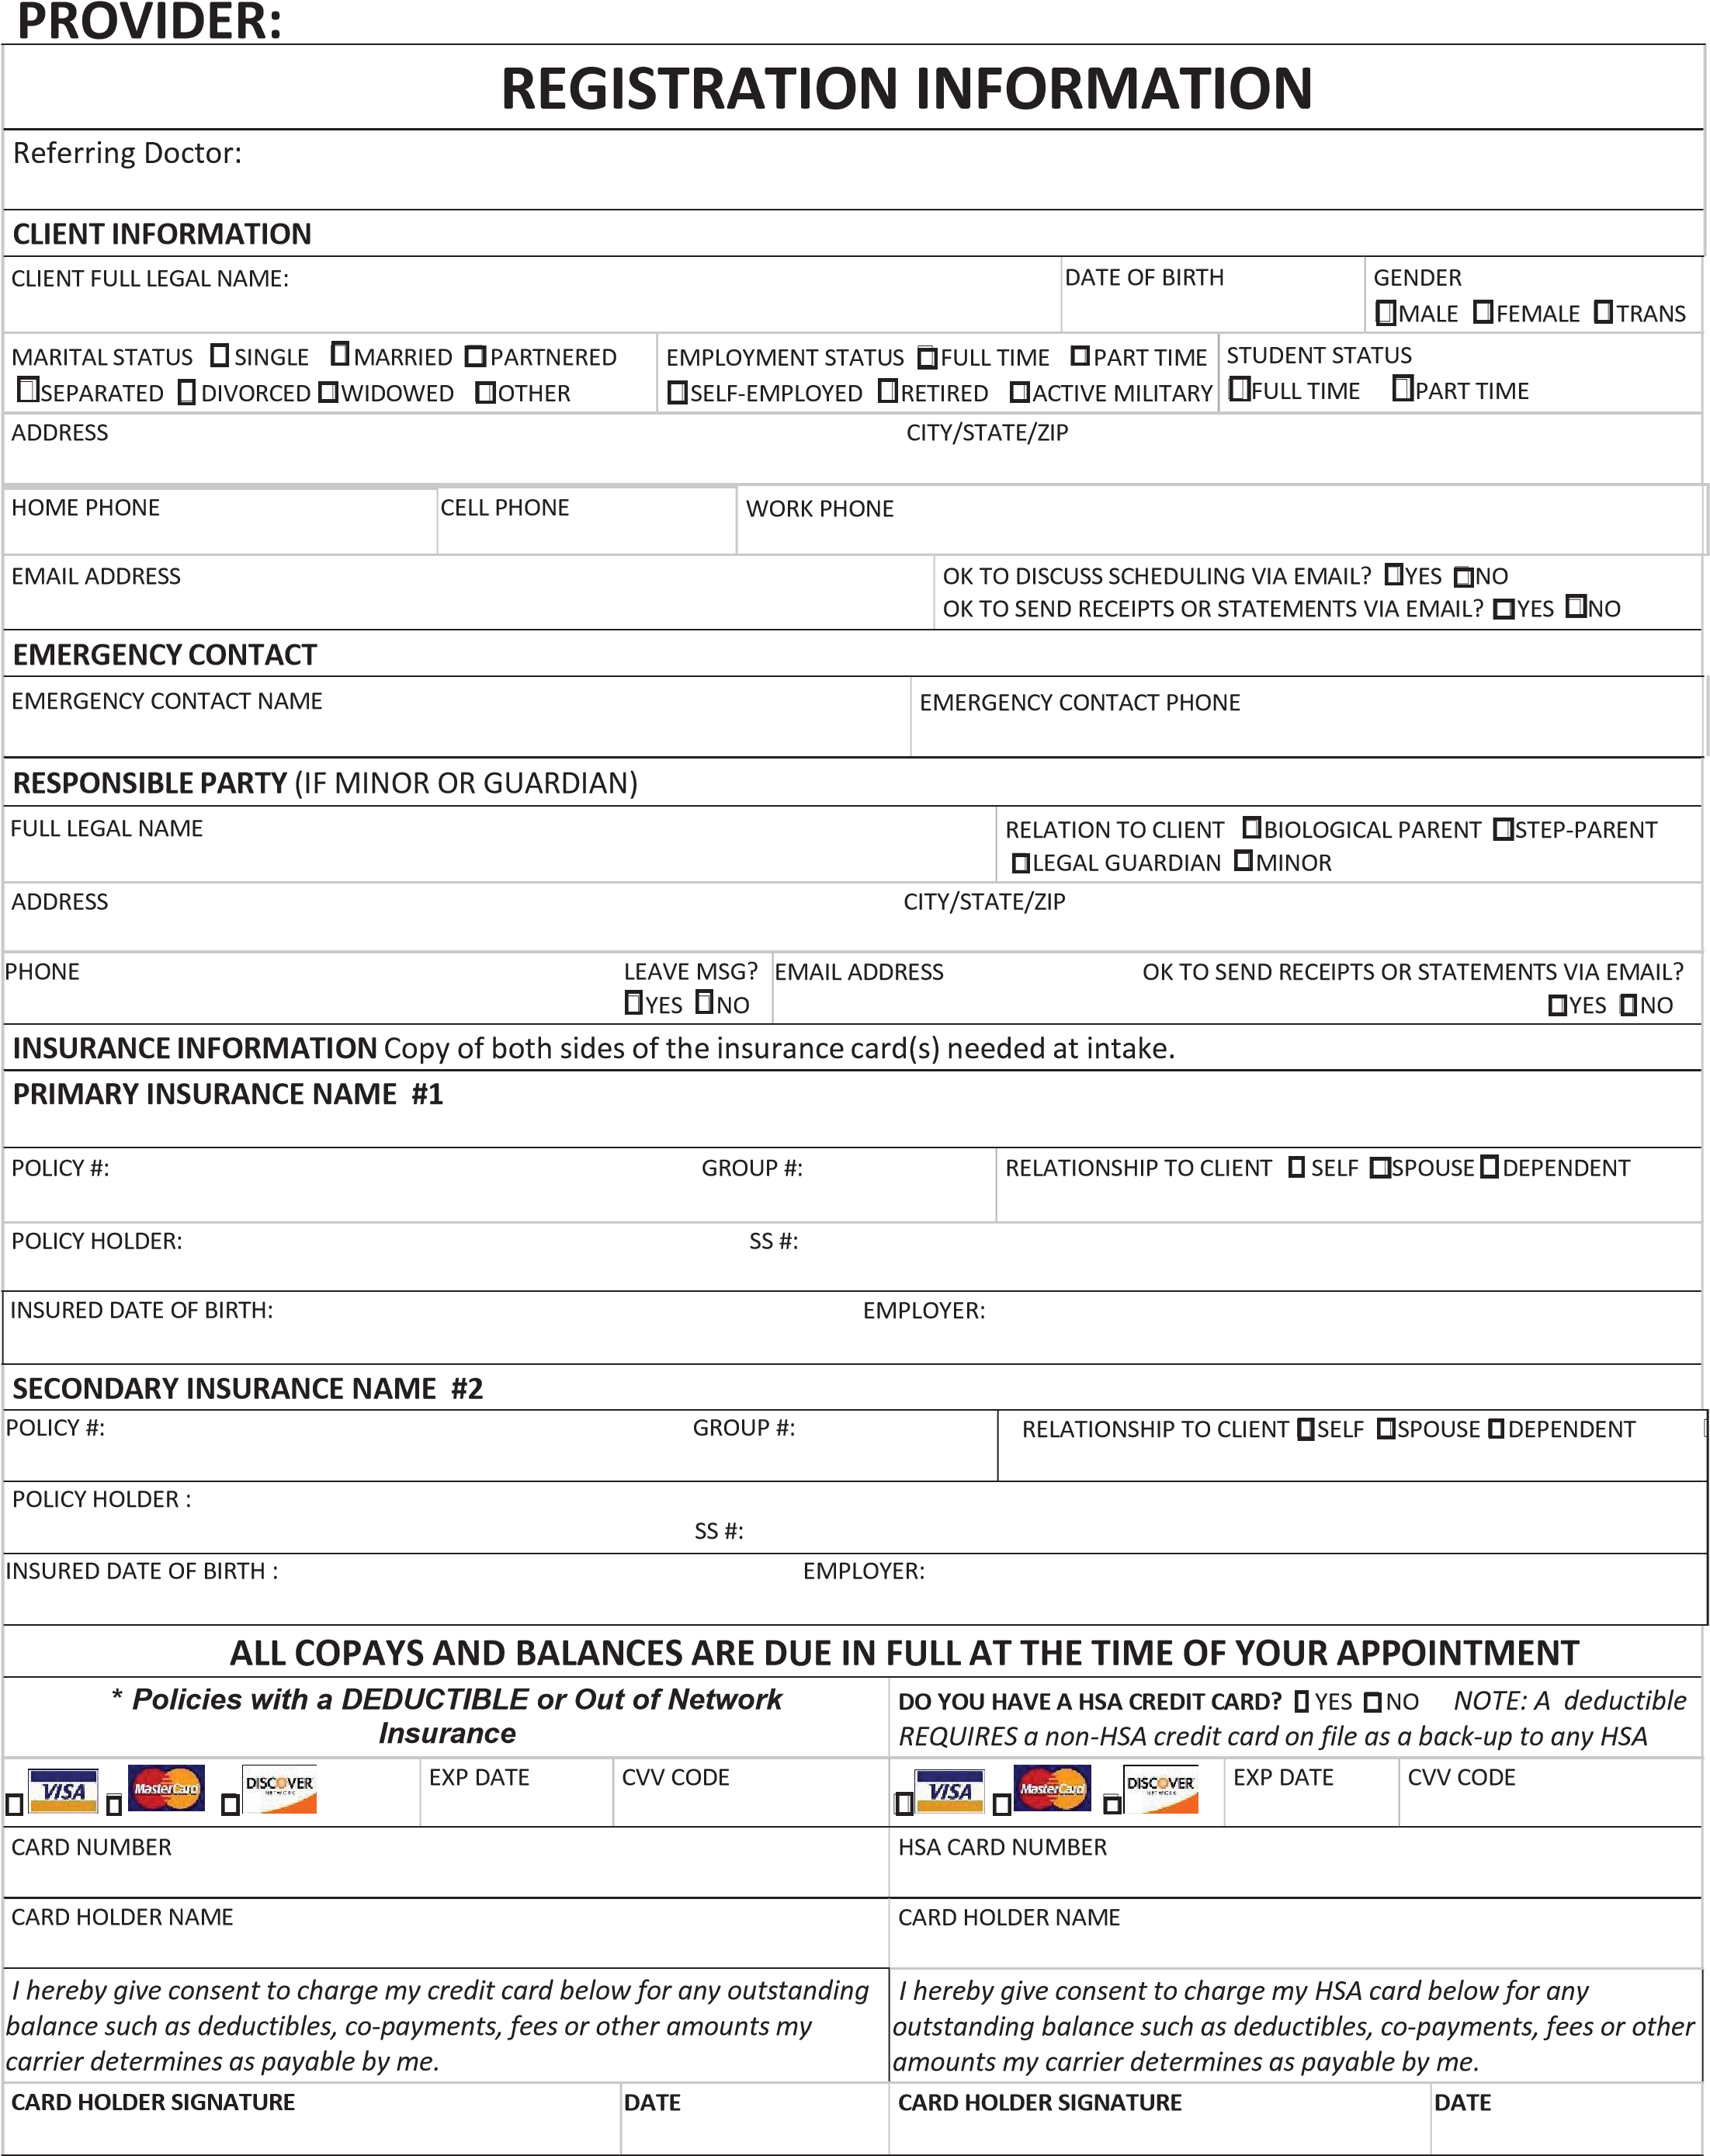
"
Page 2 of 2
CLIENT FULL LEGAL NAME: DATE OF BIRTH:
PRIVATE PAY Payment due IN FULL at the time of Service.
SERVICE DESCRIPTION (EXAMPLE: INTAKE) RATE/UNIT (EXAMPLE: $200/45-50 MIN) SERVICE DESCRIPTION RATE/UNIT
$ / $ /
IMPORTANT SIGNATURES
CLIENT FULL LEGAL NAME DATE OF BIRTH
if client is a minor, please print full legal name of parent/guardian(s) signing on behalf of the client:
PRINT FULL LEGAL NAME RELATIONSHIP TO CLIENT PRINT FULL LEGAL NAME RELATIONSHIP TO CLIENT

INSURANCE BILLING
I authorize ͺͺͺͺͺͺͺͺͺͺͺͺͺͺͺͺͺͺͺͺͺͺͺͺ;hearandafter called Medical PracticeͿ to release any medical information to our billing company for paper & electronic billing of your insurance company. I authorize my insurance company to assign benefits to Medical Practice, I understand that I am responsible for payment for services rendered by Medical Practice regardless of reimbursement for these services by the insurance company and that any inaccuracy in information on this form may result in nonpayment by my insurance company. I agree to notify the Medical Practice immediately whenever I have changes in my health plan coverage.

ACCOUNT RESPONSIBILITY
I am responsible for payment to Medical Practice for all services rendered, due at the time of the visit. I also understand that if I suspend or terminate my care and treatment, any outstanding balance will be immediately due and payable. If I default on any payment obligations as called for in this agreement, the Medical Practice reserves the right to forward my information
to collections, and an additional 30% may be assessed to my account to cover the costs of this action. There will be no obligation to provide continuing services to any client who names the Medical Practice as a creditor in any bankruptcy filing.

INFORMED CONSENT & NOTICE OF PRIVACY PRACTICES
I am consenting to treatment and have received and understand the contents of the Policies, including the Notice of Privacy Practices (HIPAA).
My signature below indicates that I have been provided a copy of, and that I fully understand & agree to all of the terms and conditions of the Policies. If I have questions, the information has been explained and/or summarized for me.
SIGNATURE(S) (CLIENT OR LEGAL GUARDIAN) DATE
SIGNATURE(S) (LEGAL GUARDIAN) DATE
"
IMPORTANT NOTICE TO ALL PATIENTS

IT IS YOUR RESPONSIBILITY TO KNOW YOUR INDIVIDUAL INSURANCE POLICY.
MANY INSURANCE POLICIES HAVE EXCLUSIONS, AND MOST HAVE DEDUCTIBLES, AND CO-PAYMENTS / CO-INSURANCE. SOME INSURANCE POLICIES MAY NOT COVER OUR SERVICES.

IT IS IMPORTANT FOR YOUT O CHECK WITH YOUR INSURANCE CARRIER TO
DETERMINE IF THE PROVIDER YOU ARE SEEING IS LISTED AS AN “IN-NETWORK” PROVIDER. IF THEY ARE NOT LISTED AS AN “IN-NETWORK” PROVIDER YOU MAY HAVE A HIGHER DEDUCTIBLE AND OR CO-PAY.

REGARDLESS OF INSURANCE COVERAGE, YOU ARE RESPONSIBLE FOR ALL BILLS NOT COVERED BY YOUR INSURANCE POLICY.

__________________________ __________________
Signature of Patient/Guardian Date

